**1.Hosting the Static Website on EC2 and accessing via public IP using VPC**

First, we start by creating a VPC. We will be using our VPC that we created earlier.

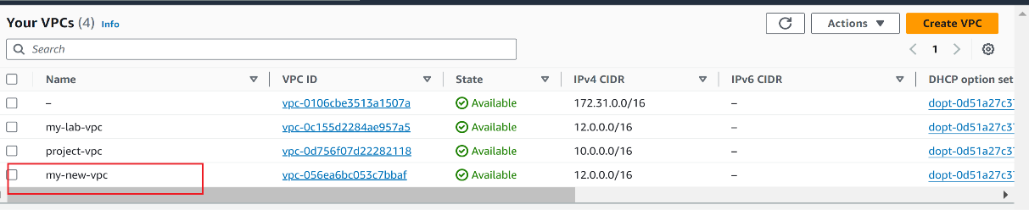

Next, we create an EC2 Instance with required configuration with our VPC

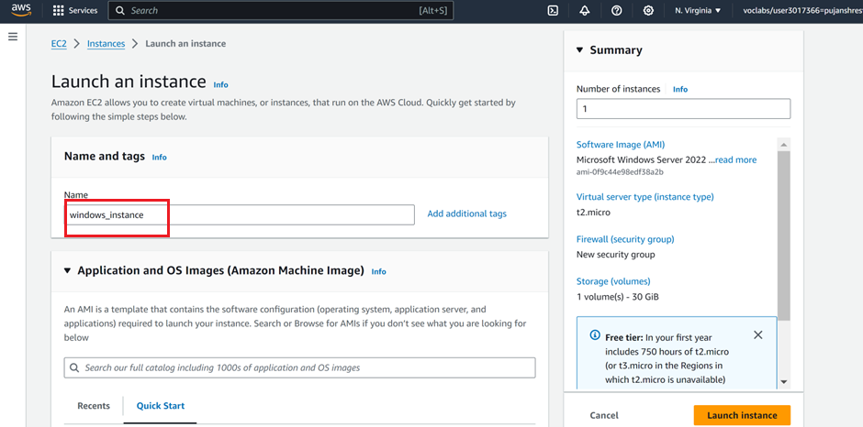

Select Windows as AMI

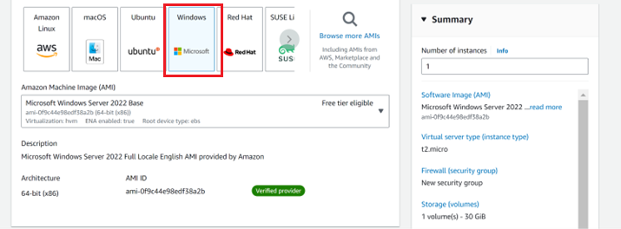

Create a new key pair name. I have named it *mywindows.pem* and download it

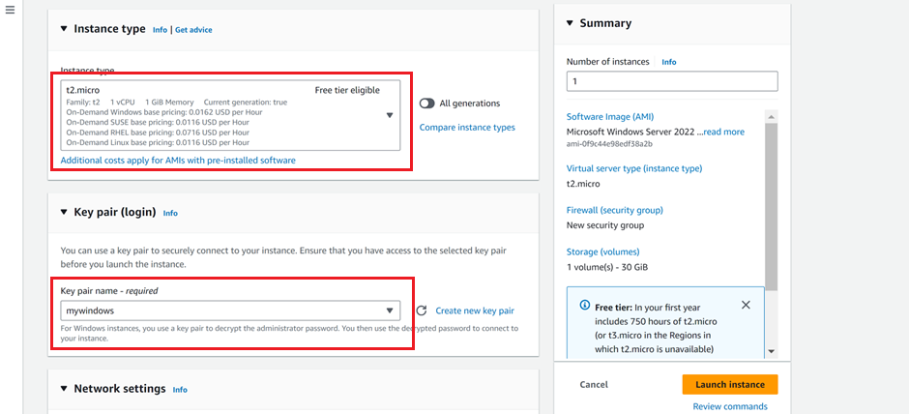

Now we auto assign our created VPC as select subnet as public subnet.

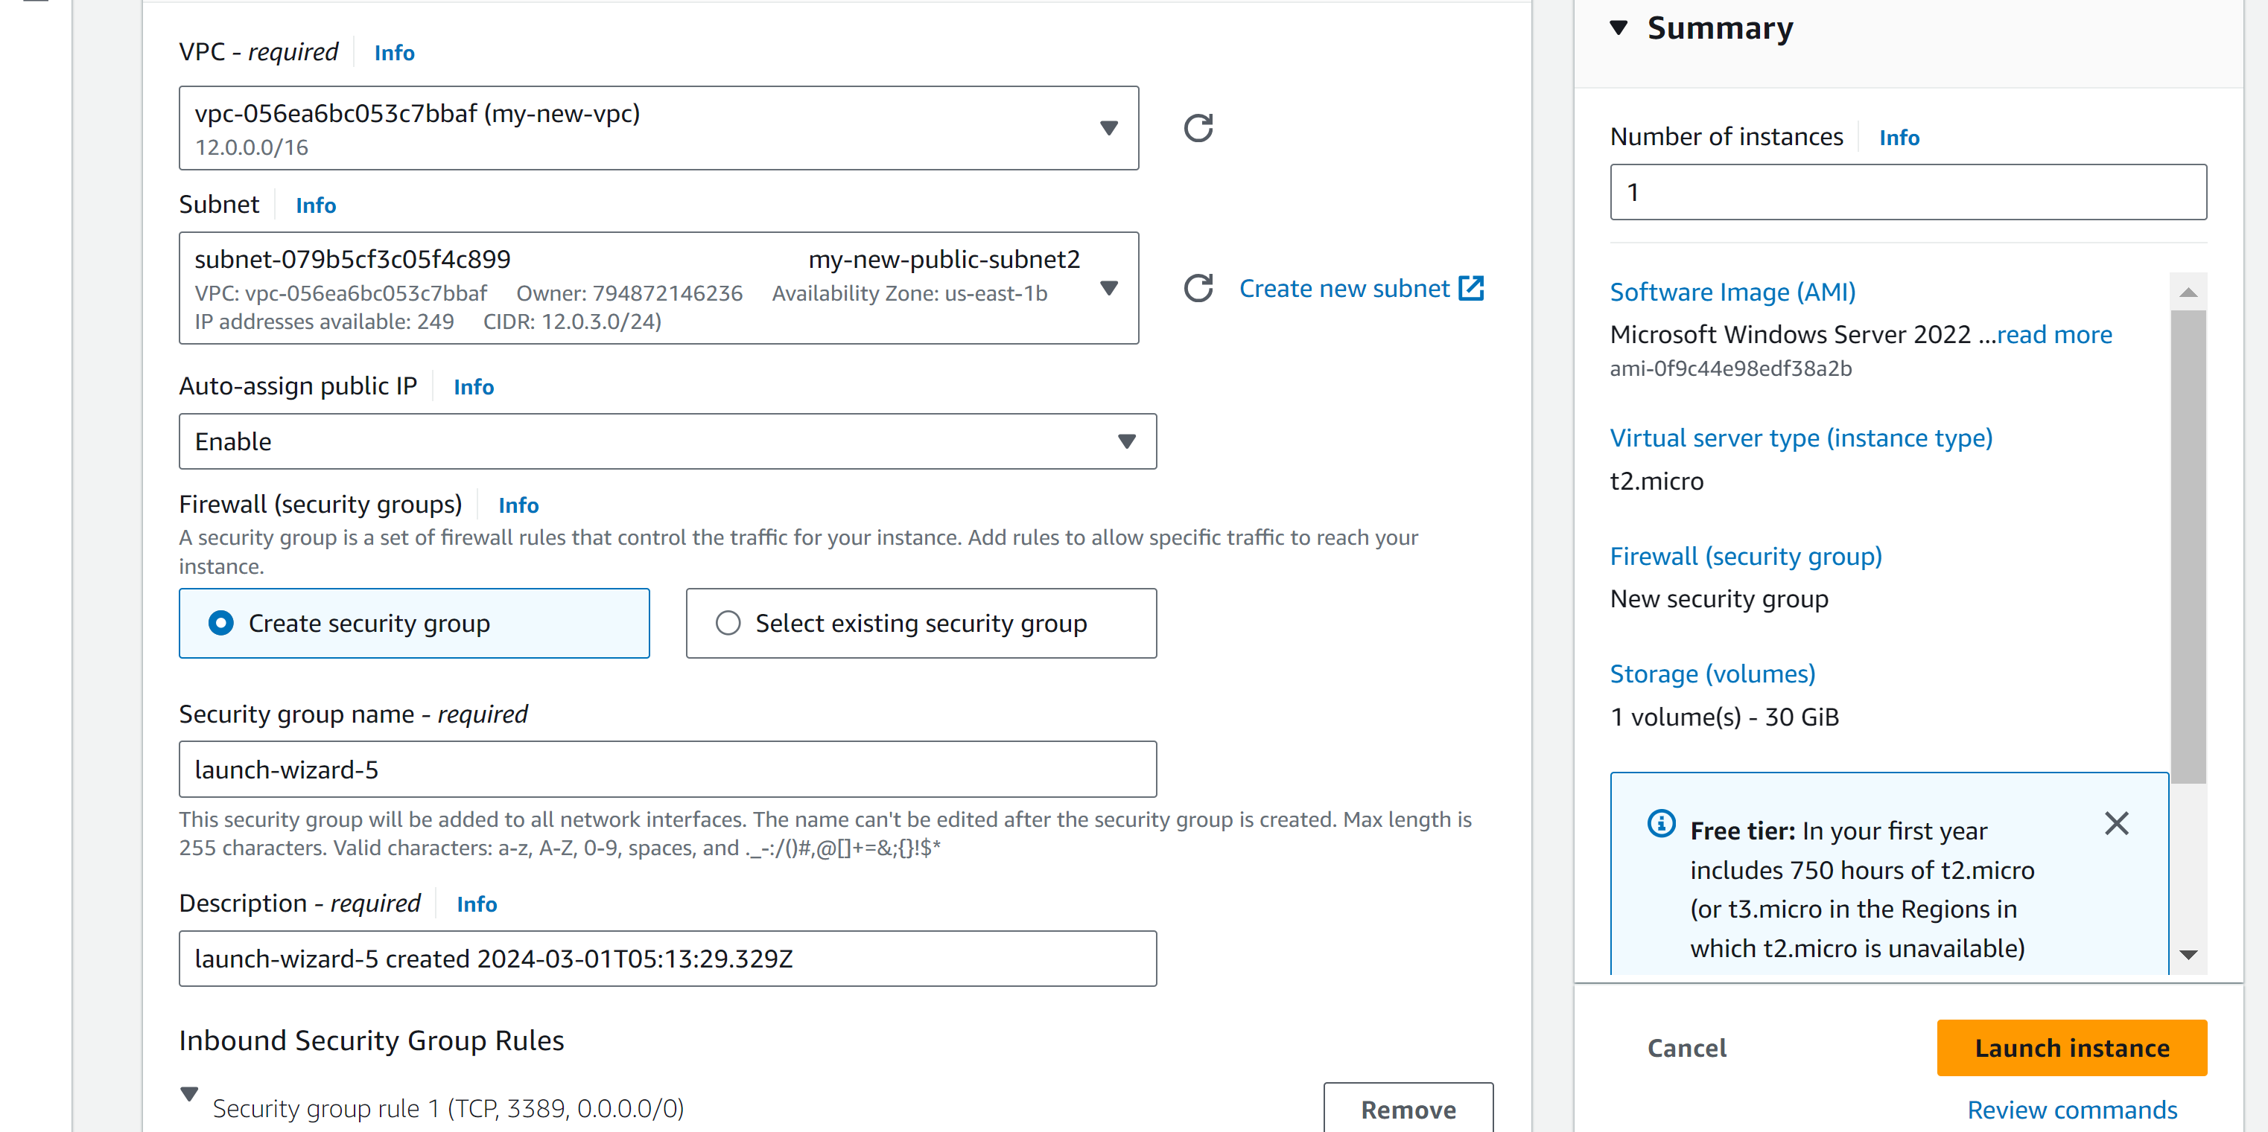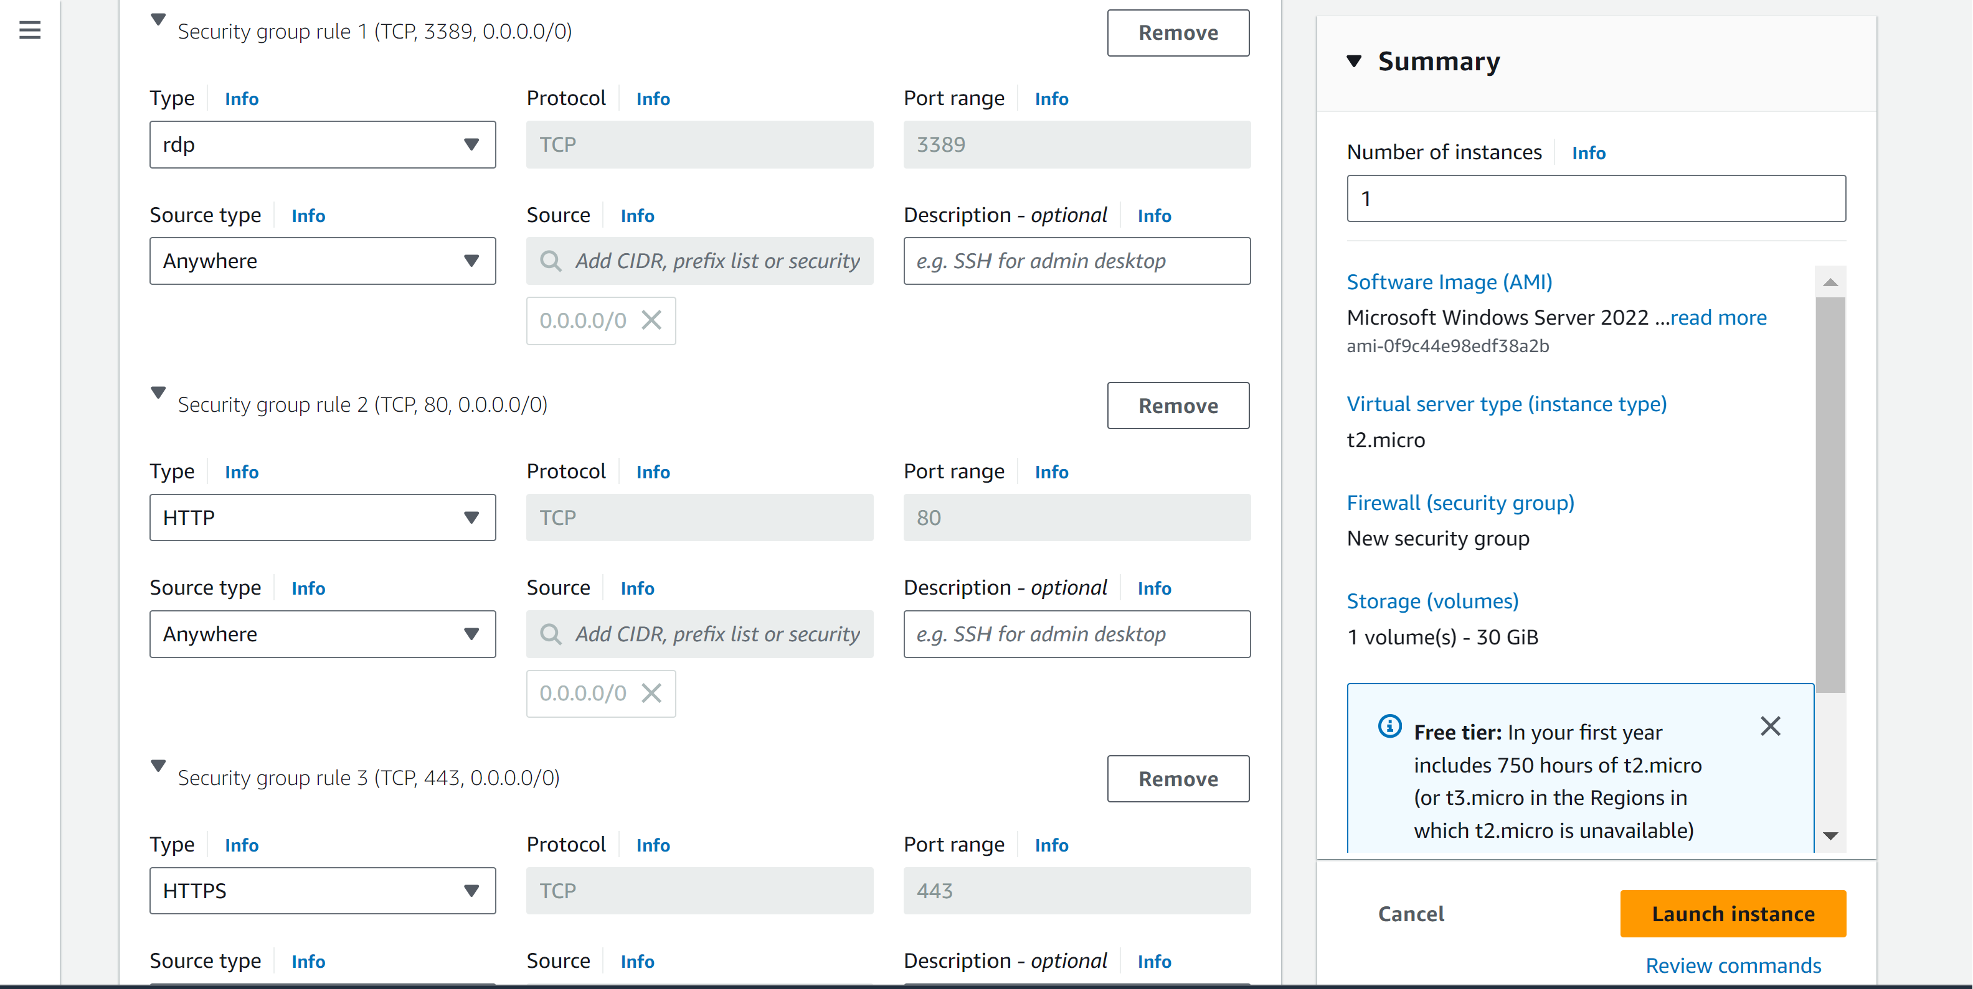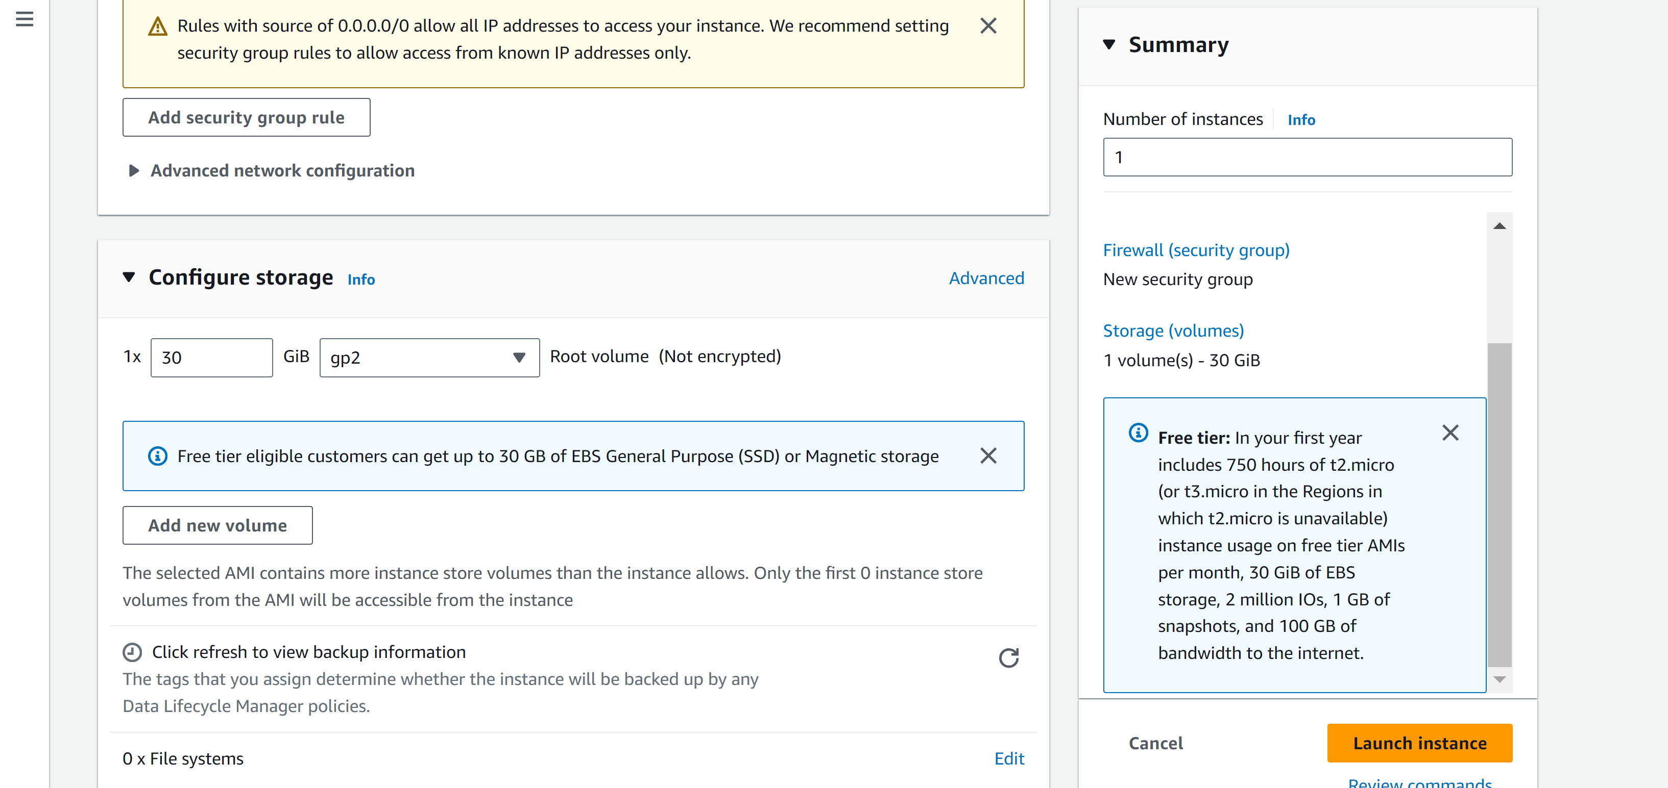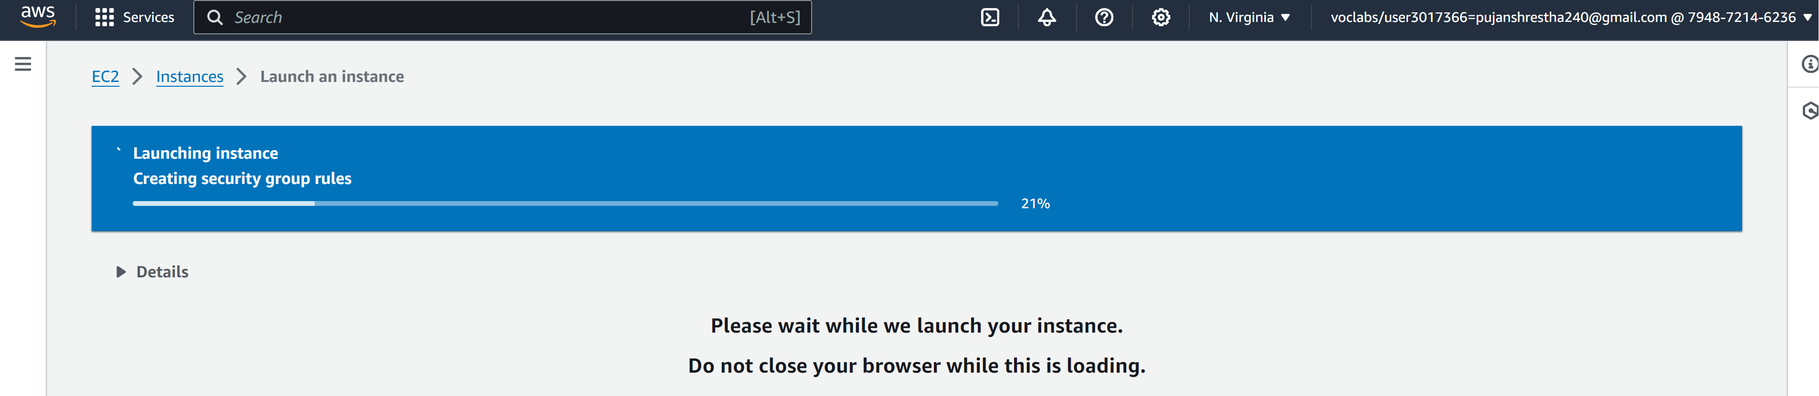

Our instance has been created with Windows as its AMI.

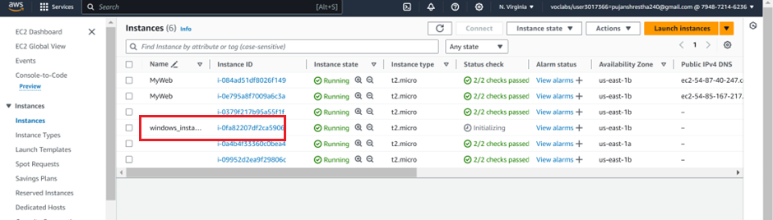

Connect EC2 and Select RDP Client

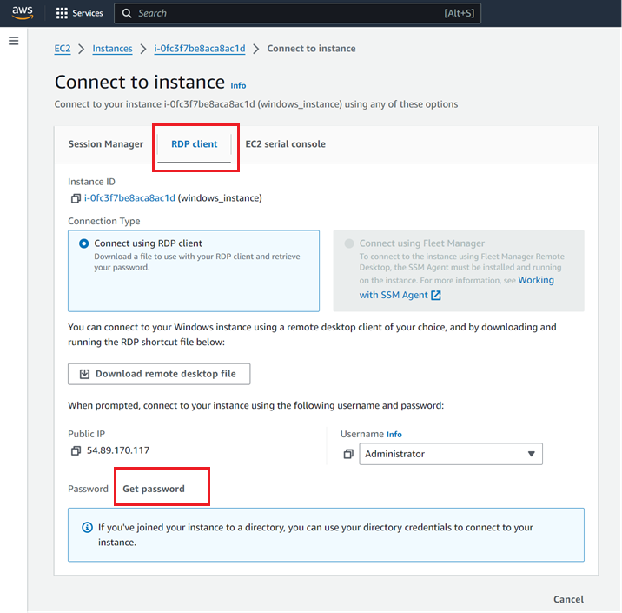

Click the get password and upload our previously saved key pair .pem file

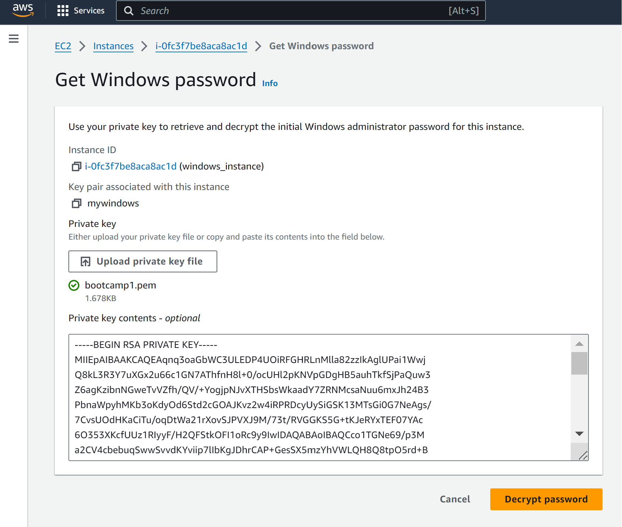

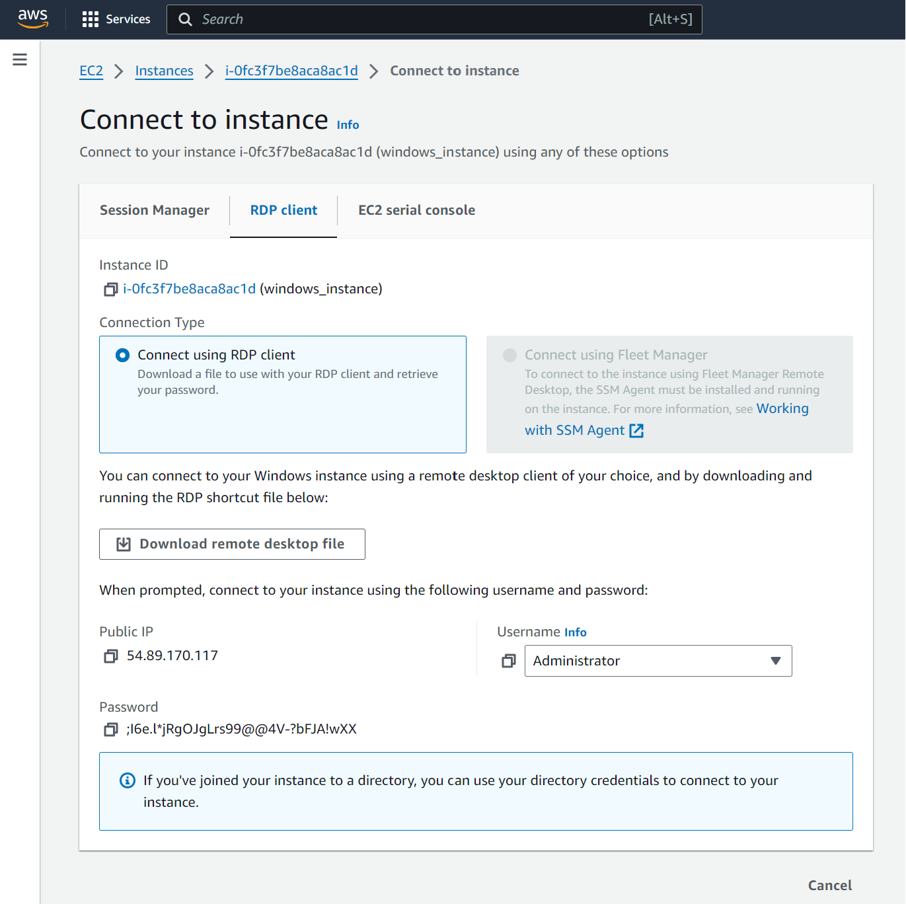

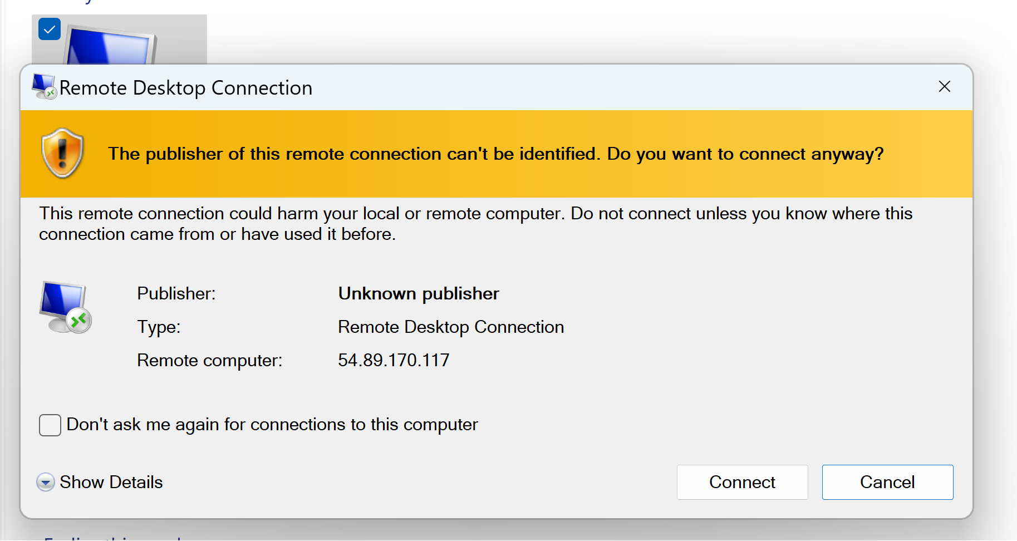

Now we can access the EC2 Machine

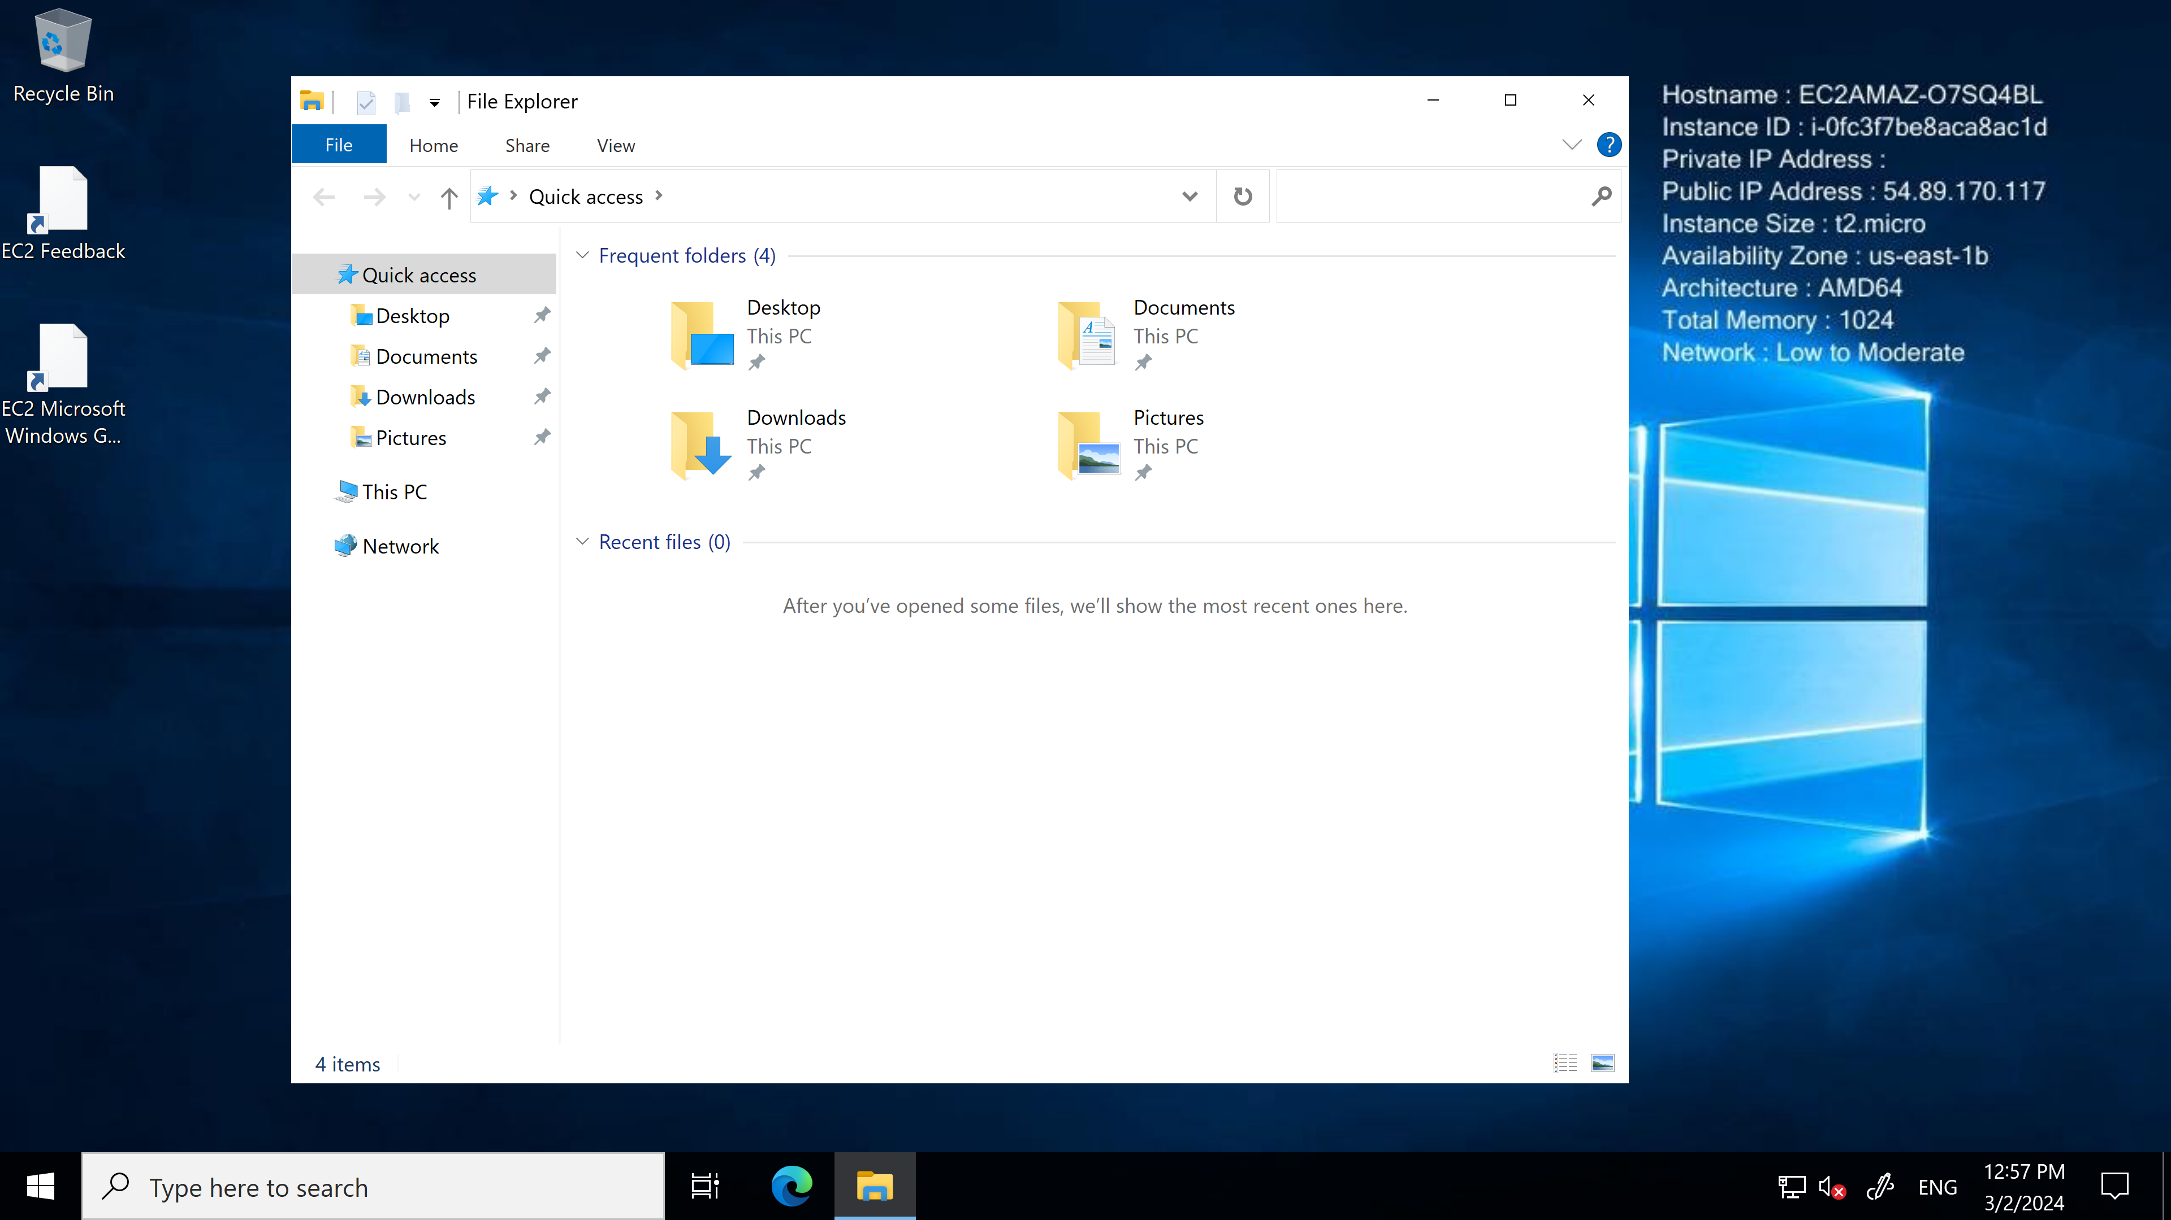

Next, we need to install xampp in our EC2 machine and create html folder and put the content for our Static Page.

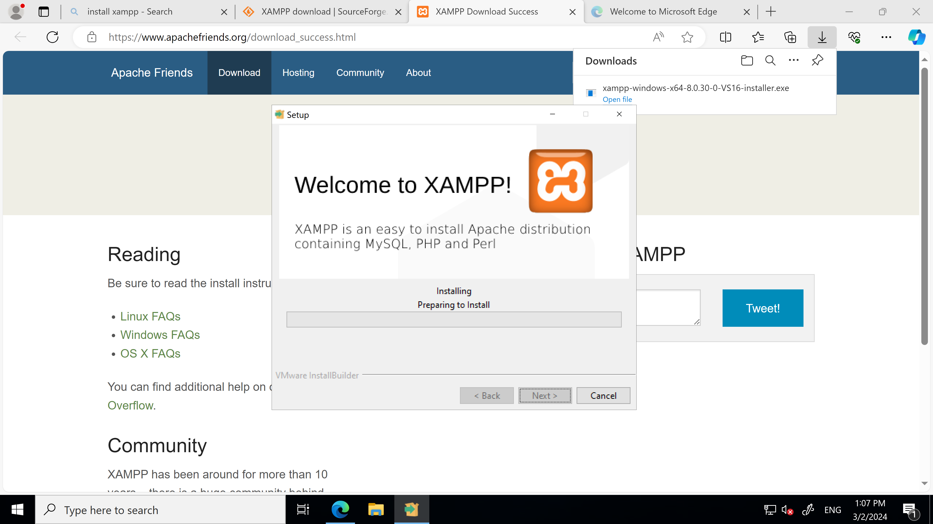

After the installation is complete (while in the Windows AMI),

Open > C:\xampp\htdocs\ here, create a folder in my case(webhostpujan) and paste html file here (in my case index.html)

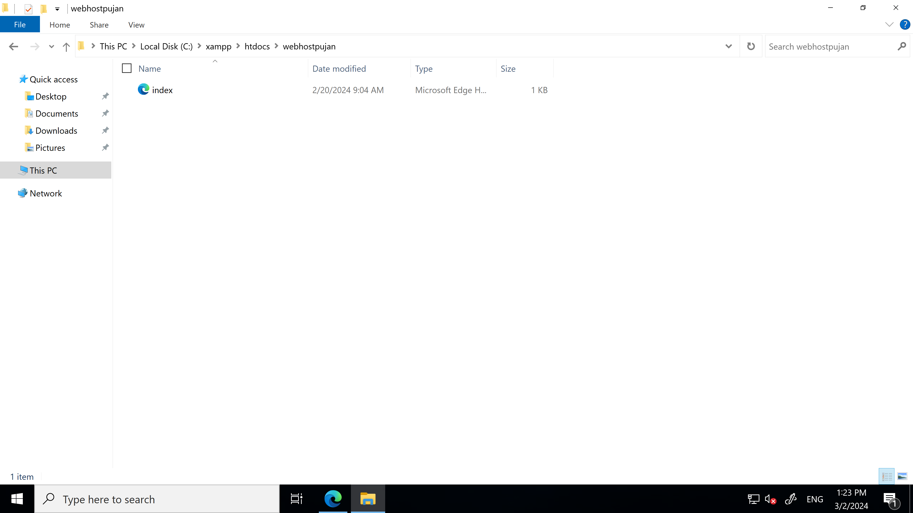

Now, copy the IP address from EC2 and access the static site.

Final Page: Here we have accessed our index.html from the Internet(Public).